Copy | Graphic | Alt text
We all need help and support at some point in our lives  If your family is ever facing a difficult situation, we can help at your local Family Hub ❤  Get support on family relationships, childhood development, emotional health and conflict at home ‍‍  Find your local Family Hub at www.wakefieldfamiliestogether.co.uk | 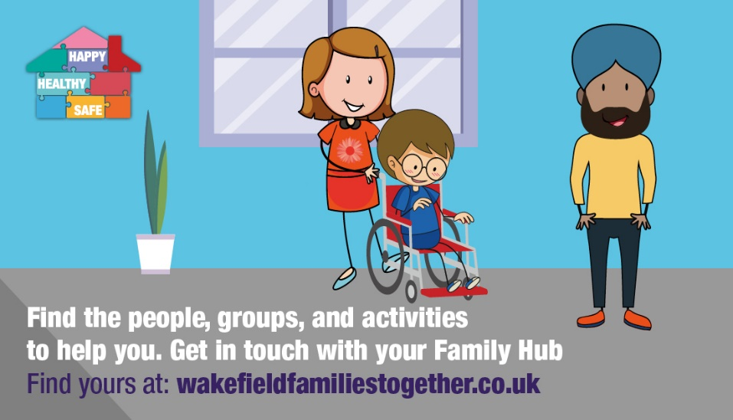 | A cartoon of a woman pushing a child in a wheelchair, a man stands nearby in a family hub.  Text reads: find the people, groups, and activities to help you. Get in touch with your Family Hub find yours at wakefieldfamiliestogether.co.uk
If you or your family was struggling with an issue, would you know where to go?  Telling your school can be the first step to get the help you need  The Team Around the School will provide support to ease your worries on behaviour, attendance and emotional wellbeing  Learn more https://www.wakefieldfamiliestogether.co.uk/about-us/the-team-around-approach/ | 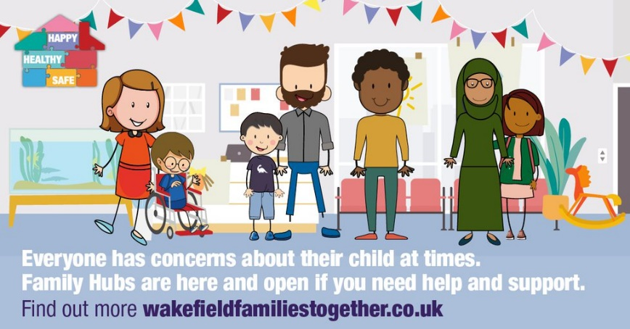 | A cartoon of adults and children, with text that says: “Everyone has concerns about their child at times. Family Hubs are here and open if you need help and support. Find out more wakefieldfamiliestogether.co.uk”
😟 Are you concerned about your child’s development, behaviour, school attendance or mental health?  ❤ At your local Family Hub, support is available to direct you to the right place to ease your worries.  👩‍👦 Whether you’re a parent, carer or young person – we’re here to help.  Find your local Family Hub at www.wakefieldfamiliestogether.co.uk | 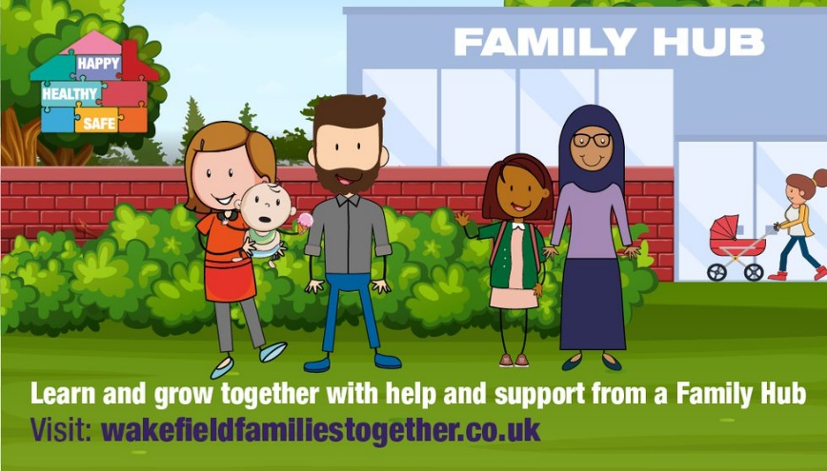 | A cartoon of people outside a Family Hub building, with text that says: “Learn and grow together with help and support from a family hub. Visit wakefieldfamiliestogether.co.uk”
Telling your school about a family issue can be the first step to get help  If you or your family are struggling with behaviour, attendance and emotional wellbeing – the Team Around the School will provide support for your family  Learn more https://www.wakefieldfamiliestogether.co.uk/about-us/the-team-around-approach/ | 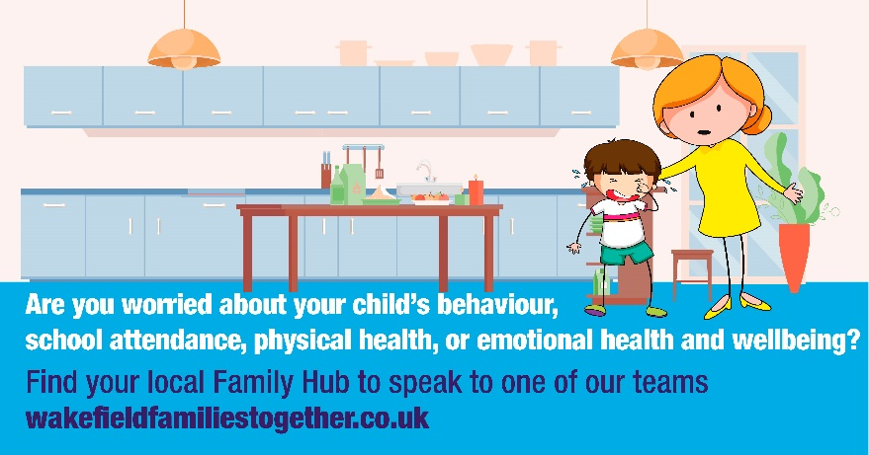 | Mother comforts child in their kitchen.  Text reads: Are you worried about your child’s behaviour, school attendance, physical health, or emotional health and wellbeing? Find your local Family Hub to speak to one of our teams wakefieldfamiliestogether.co.uk
Your local Family Hub is a one-stop shop for parents, carers and young people to access whole family support  Find your local Family Hub at www.wakefieldfamiliestogether.co.uk | 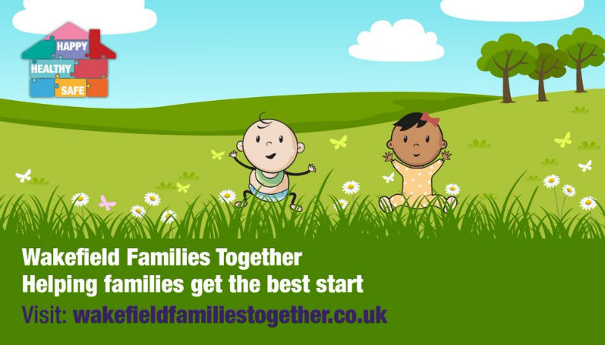 | A cartoon of toddlers playing in a field with text that says “Wakefield Families Together. Helping families get the best start. Visit: wakefieldfamiliestogether.co.uk”

